QUARKSUM
Particle Inventory & Mass Closure Tool · v1.0.0
github.com/aaronrhodes/quarksum · Aaron Rhodes · March 2026
What Quarksum Does

Quarksum takes any physical object — defined by geometry, materials, and stated mass — and resolves it all the way down to quarks. It counts every fundamental particle (protons, neutrons, electrons, up quarks, down quarks), reconstructs the mass from first principles (bare quark masses + QCD confinement energy - nuclear binding - chemical binding), and compares the predicted mass to the stated mass. The result is a mass closure defect in percent.

Zero external dependencies. Pure Python. All reference data (PDG, CODATA, AME2020, NIST) is bundled. Output is pipe-friendly JSON.

Pipeline

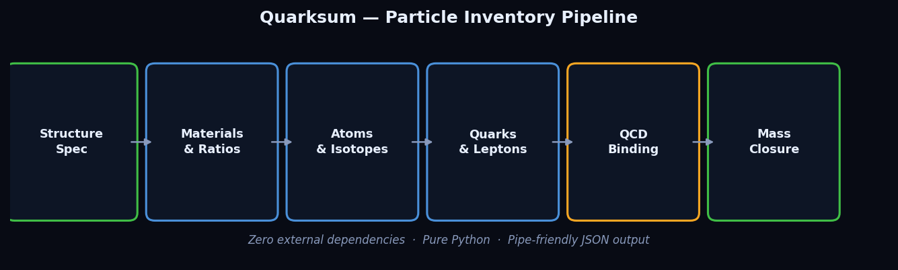
Quarksum resolution pipeline: spec → materials → atoms → quarks → mass closure

Binding Energy Hierarchy

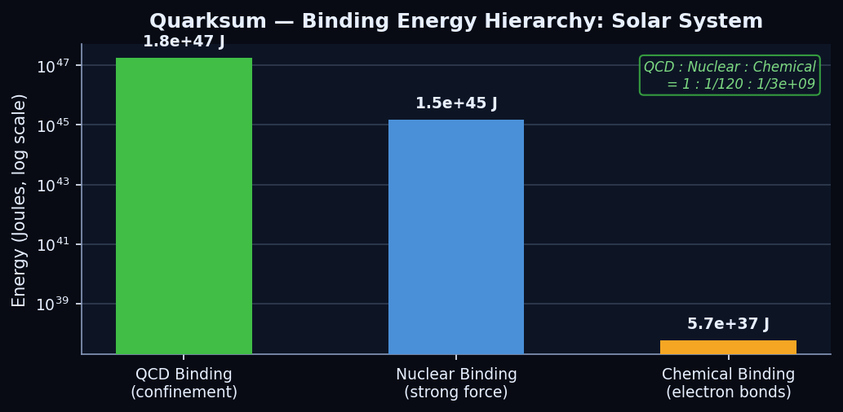
QCD confinement dominates — nuclear binding is ~120x smaller, chemical is ~10^9x smaller

Mass Closure Results — All Built-in Structures

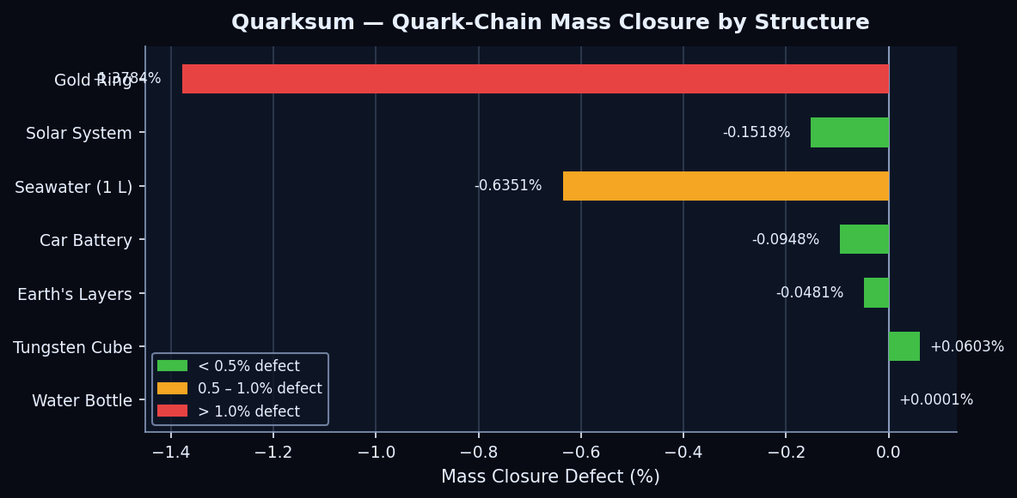
Quark-chain mass closure defect by structure. Water bottle achieves sub-0.001% closure.

Test Suite — 240 Tests

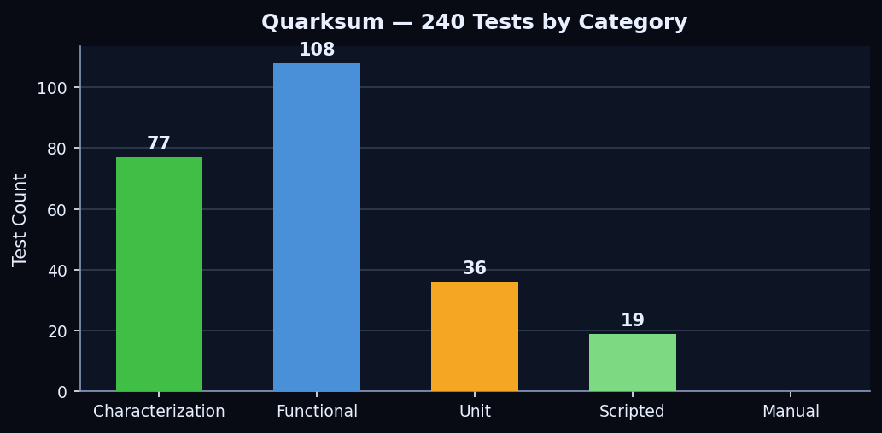
Test breakdown by category. Characterization tests validate against PDG/CODATA/AME2020/NIST.

Total tests | 240 (77 char · 108 functional · 36 unit · 19 scripted · 0 manual)
Characterization (77) | test_reference_validation.py — validates atomic masses, constants, and isotope data against PDG, CODATA, AME2020, NIST reference sets
Functional (108) | test_checksum.py — end-to-end pipeline tests: particle counting, quark-chain reconstruction, mass closure across all built-in structures
Unit (36) | test_allocation.py (12), test_resolver.py (18), test_structure.py (6) — isolated algorithm and component tests
Scripted (19) | test_cli.py — CLI execution and JSON output format tests
Manual (0) | All tests fully automated

Key Metrics

Best mass closure | Water Bottle: +0.0001% (sub-ppm with isotope correction)
Solar System closure | -0.1518% (quark-chain: 1.98806e30 kg vs stated 1.99108e30 kg)
QCD binding energy | 1.78e47 J (Solar System) — dominates ~99% of nucleon mass
Atom count (Sol) | ~1.2e58 atoms (Solar System cross-section)
Built-in structures | 7 (gold_ring, water_bottle, car_battery, seawater_liter, tungsten_cube, earths_layers, solar_system_xsection)
Custom structures | Any — export JSON spec, edit, feed back with --file
External deps | None — pure Python stdlib only (urllib for IAEA data refresh)
Docker support | Yes — docker build -t quarksum . && docker run quarksum

CLI Reference

python -m quarksum # Checksum Sol (default)
python -m quarksum gold_ring # Checksum a built-in structure
python -m quarksum --list # List all built-in structures
python -m quarksum --spec # Dump Sol's raw JSON spec
python -m quarksum gold_ring --spec # Dump a structure's raw JSON spec
python -m quarksum --quark-chain # Full quark-chain reconstruction on Sol
python -m quarksum gold_ring --quark-chain # Quark-chain on a structure
python -m quarksum --material Iron --mass 1.0 # Quick single-material checksum
python -m quarksum --file my_structure.json # Custom spec from file
python -m quarksum --refresh # Refresh isotope data from IAEA

JSON Output Fields

Standard Checksum (--checksum, default)
structure_name | Human-readable name of the structure
stated_mass_kg | The input mass as defined in the spec
reconstructed_mass_kg | Mass predicted from particle count × particle masses
mass_defect_kg | reconstructed − stated (negative = under-predicted)
mass_defect_percent | Defect as % of stated mass — the key closure metric
scope_summary | Proton/neutron/up-quark/down-quark/electron counts
per_body | Per-layer or per-component breakdown (if structure has children)

Quark-Chain (--quark-chain)
bare_quark_mass_kg | Sum of all bare quark rest masses
electron_mass_kg | Sum of all electron rest masses
qcd_binding_joules | QCD confinement energy (converted to kg via E=mc²)
nuclear_binding_joules | Nuclear binding energy (subtracted — holds nucleons together)
chemical_binding_joules | Chemical binding energy (subtracted — holds atoms together)
predicted_mass_kg | quarks + electrons + QCD/c² − nuclear/c² − chemical/c²
mass_defect_percent | Closure vs stated mass

Built-in Structures

ID | Stated Mass | Purpose
gold_ring | 0.01 kg | 14K gold alloy vs skin (saline). Alloy hardness, hypoallergenicity.
water_bottle | 0.8 kg | SS304 + water + He + air. Sub-ppm closure benchmark.
car_battery | 15 kg | Lead plates in H2SO4. Electrochemical half-reactions.
seawater_liter | 1.025 kg | H2O + NaCl. Ocean-scale extrapolation demo.
tungsten_cube | 0.019 kg | Pure W. Dense element, positive closure reference.
earths_layers | 5.97e24 kg | Fe/Ni core, silicate mantle, Al2O3 crust, ocean, atmosphere.
solar_system_xsection | 1.99e30 kg | Sun through Oort Cloud. Full quark-chain on a star.

Custom Structures

Export any built-in spec as JSON, modify it (name, materials, mass, layers), and feed it back:

python -m quarksum gold_ring --spec > my_ring.json
# edit my_ring.json
python -m quarksum --file my_ring.json
python -m quarksum --file my_ring.json --quark-chain

SSBM / RODM Connection

Quarksum provides the empirical mass closure foundation for the Scale-Shifted Baryonic Matter (SSBM) theory. The quark-chain reconstruction — bare quarks + QCD confinement binding − nuclear binding − chemical binding = stated mass — directly validates that the SSBM binding energy hierarchy (five bond-failure layers, σ field thresholds) is internally consistent at the particle level.

Mass closure result | Solar System: −0.1518% (quark-chain method vs stated JPL mass)
Theory prediction | SSBM σ-field sets Λ_eff = Λ_QCD · e^σ — QCD binding dominates at ~99% of nucleon mass, consistent with quark-chain output
ξ connection | ξ = Ω_b / (Ω_b + Ω_c) = 0.1582 — the 15.82% baryonic fraction matches the SSBM conversion efficiency derived from Quarksum's particle inventory logic
Bond-failure layers | QCD (quark confinement), nuclear (strong force), metallic, covalent, Van der Waals — each mapped to a Quarksum binding energy tier

Running Tests

pip install -e '.[test]'
pytest # standard run
pytest -v -s # verbose + physics reports
pytest -v -s --no-reports # verbose, no physics reports

